Cortina Community Services District

PO Box 43

Arbuckle CA 95912

Karl Drexel, General Manager

(707) 318-7369

[karl@kdmanagement.us](mailto:karl@kdmanagement.us)

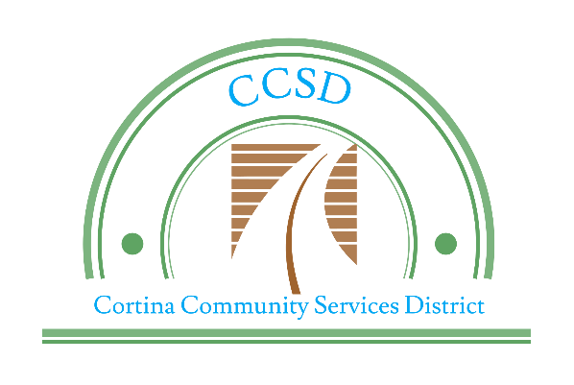

|  |
| --- |
| Rod Bradford, Chairman |
| Karen Gage, Secretary |
| Dolores Gomez, Director |
| Kimberly Valles, Director |
| Jesika Johnson, Director |

**AGENDA**

Regular Meeting

Arbuckle Golf Course

5918 Hillgate Rd, Arbuckle, CA 95912

DECEMBER 27, 2021, at 6 pm

1. CALL TO ORDER AND ESTABLISH QUORUM:

Cortina CSD Board of Directors Roll Call: Chair: Bradford____ Members: Gage_____ Gomez_____

Valles _____ Johnson_____

1. PLEDGE OF ALLEGIANCE:
2. PUBLIC COMMENTS: *(Each speaker is limited to two minutes)*

*Members of the public are appreciated for taking the time to attend this meeting and provide comments on matters of District business. Any member of the public may address the Board relating to any matter within the District’s jurisdiction. This need not be related to any item on the agenda; however, the Board with cannot act on an item unless it was noticed on the agenda*

**CANCELED**

1. CONSENT CALENDAR:

*Items listed on the consent agenda are considered routine and may be enacted in one motion.*

*Any item may be removed for discussion at the request of the Board or the Public.*

1. Approval of Minutes: Regular Meeting November , 2021
2. Ratification of Disbursements: November 1, 2021 through December 17, 2021
3. Approve Payables for January 2022
4. Review and Acknowledge YTD Financials
5. DISCUSSION / REPORTS: ACTION ITEMS:
6. Update Board on Grice tree removal.
7. Update Board on RFP for Landscape Maintenance
8. CORRESPONDENCE, STAFF and BOARD MEMBER REPORTS:
9. ADJOURNMENT:

Meeting agendas and written materials supporting agenda items, if produced, can be received by the public for free in advance of the meeting by any of the following options:

* A paper copy mailed pursuant to a written request and payment of associated mailing fees.
* An electronic copy received by email. Note – if you would like electronic copies, please email the board at ArbuckleCCSD@gmail.com prior to the Board meeting
* On the CSD Website on the Friday proceeding each regular meeting date. A limited amount of meeting materials will also be available at the meeting.

Americans with Disabilities Act Compliance: If you require special assistance to participate in Board Meetings, please contact the board at ArbuckleCCSD@gmail.com. Advance notification will enable the District to make reasonable arrangements to insure accessibility. The next Cortina CSD Board Meeting is scheduled to be held on December 27, 2021 at 6:00 pm