**MORE FREQUENTLY ASKED QUESTIONS**

|  |  |  |  |
| --- | --- | --- | --- |
| Where can I find more information on: | |  | |
| … the date of the next Board of Directors meeting? | | There will be a link to the website | |
| … copies of the latest minutes from the board meetings? | | There will be a link to the website | |
|  | |  | |

Your Community Needs Your Help!

This a bright shiny new, thriving community that we live in and we all need to pitch in and do our part to keep it that way. What can you do to help? Well, here are a few ways…

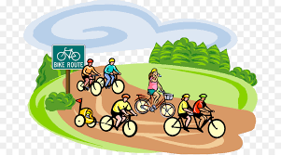

* Please don’t throw your garbage or cast-offs away on the bike trail or public landscape areas. They are NOT dumping areas!
* Please don’t allow your children to climb or destroy public property fences and landscaping.
* Please

***Let’s use our tax dollars as they were intended… not for cleaning up vandalism.***